Project Design Phase
Solution Architecture

Date | 15 February 2026
Team ID | LTVIP2026TMIDS79623
Project Name | Educational Organisation Using ServiceNow
Maximum Marks | 4 Marks

Solution Architecture:
Solution architecture is a complex process – with many sub-processes – that bridges the gap between business problems and technology solutions.
Solution Architecture Diagram:
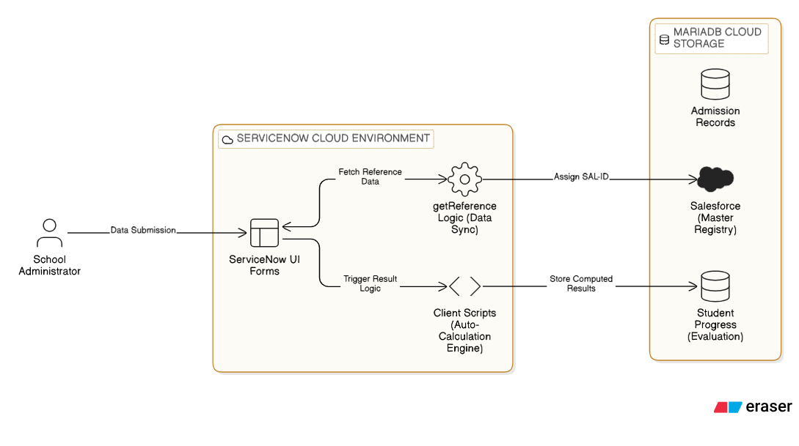
The architecture bridges the business problem of manual paperwork by using a 3-tier cloud structure. Data submitted via UI forms is processed by automated Client Scripts and synchronized with a MariaDB-based Salesforce Master Registry
Component | Technical Role
ServiceNow Instance | The core cloud platform hosting the application and data.
Custom Tables | The foundation of the system, consisting of Salesforce (Master), Admission, and Student Progress tables.
Client Scripts | JavaScript logic that handles getReference for auto-filling data and automated mark calculations.
Process Flow | A visual lifecycle tracker for student admissions (New —> Joined —> Closed).
UI Forms | Custom digital interfaces designed for accurate data entry by school staff.
Update Sets | The deployment architecture used to move this solution from Dev to Production.

